**Intermediate**

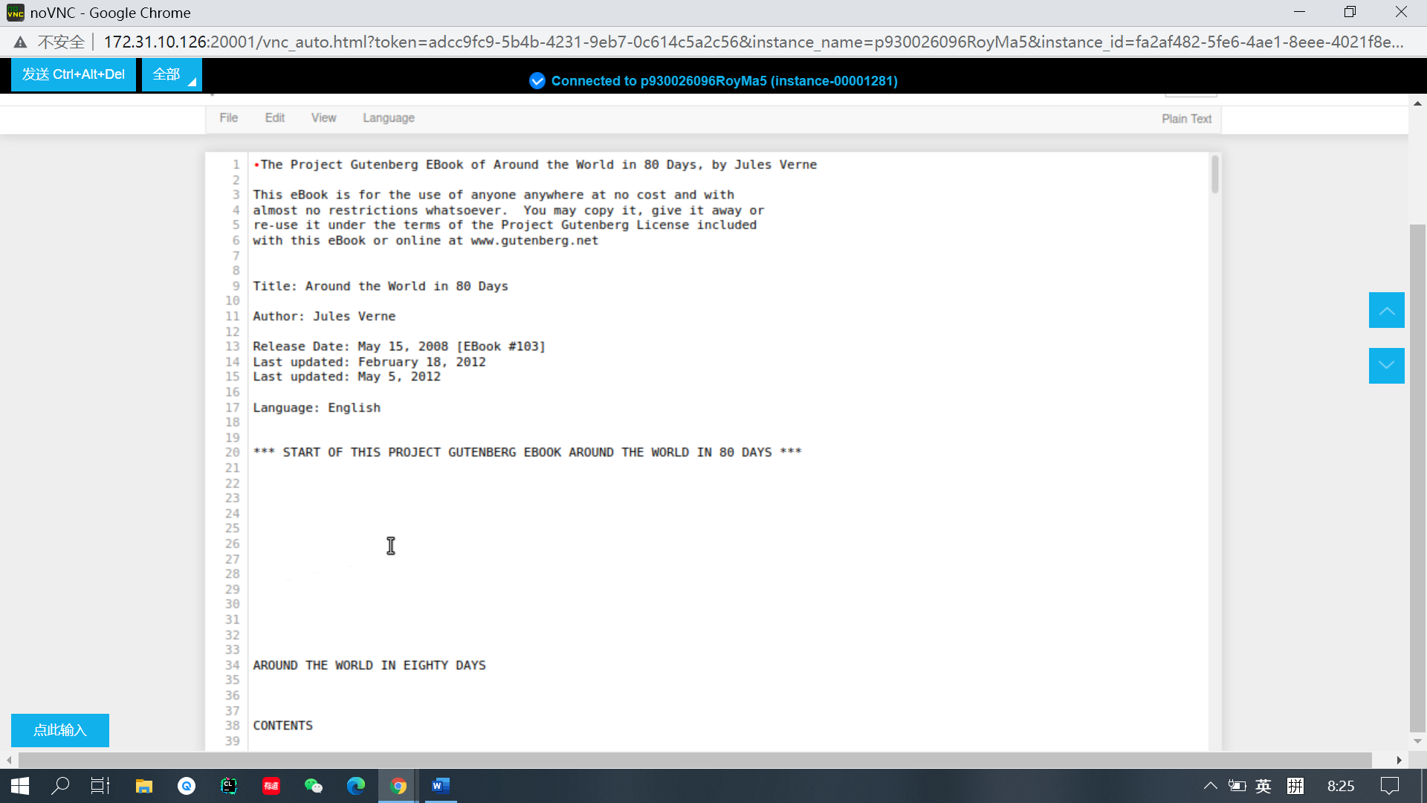

**The English text file.**

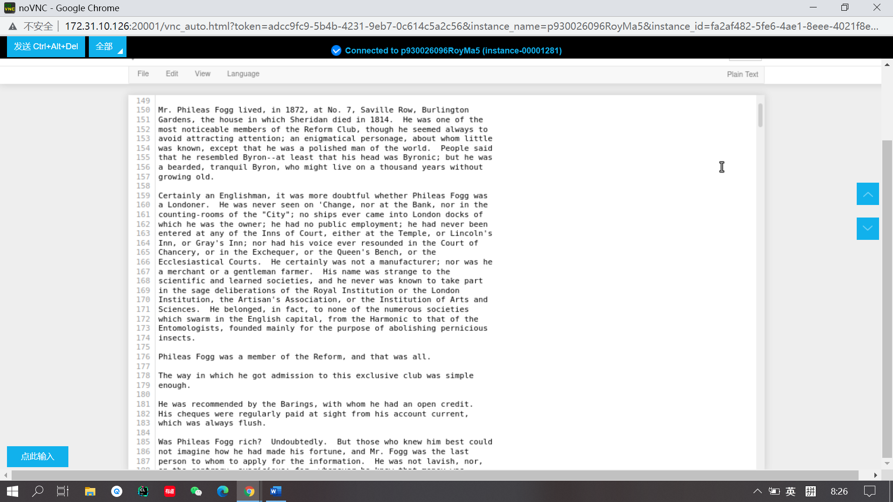

**The content of English text file.**

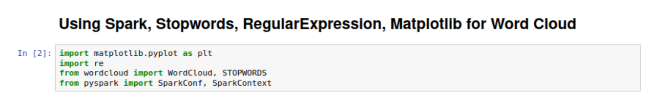

**Using Spark, stop words and regular expression, matplotlib for word cloud.**

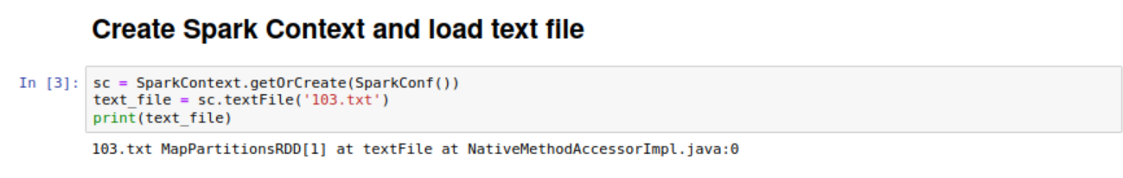

**Create Spark context and load text file.**

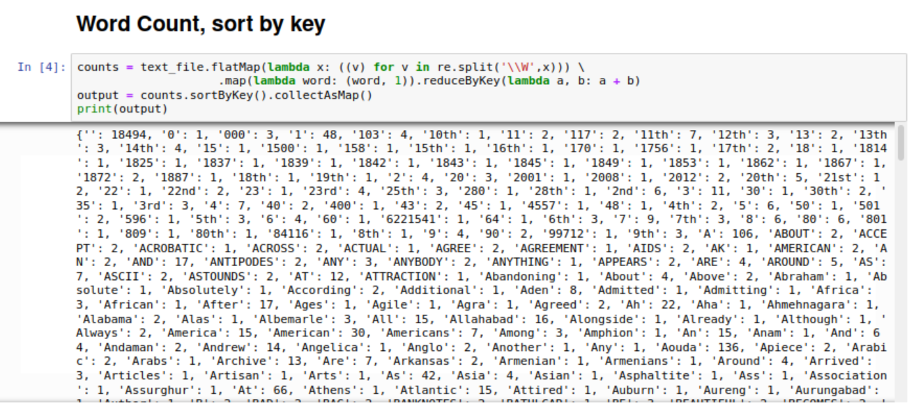

**Word count and sorted by key.**

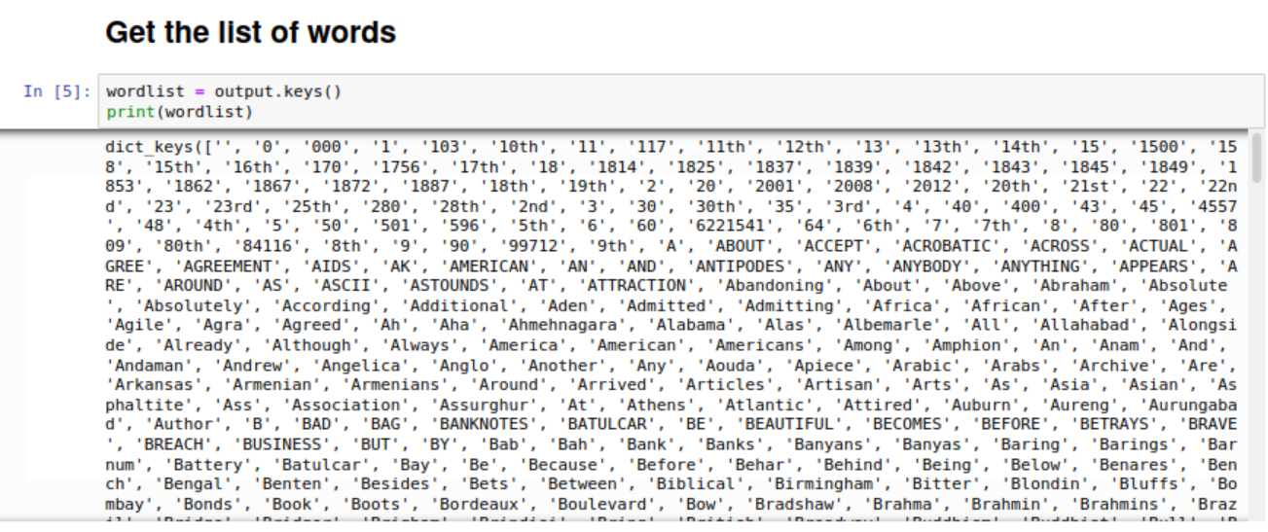

**Get the list of words.**

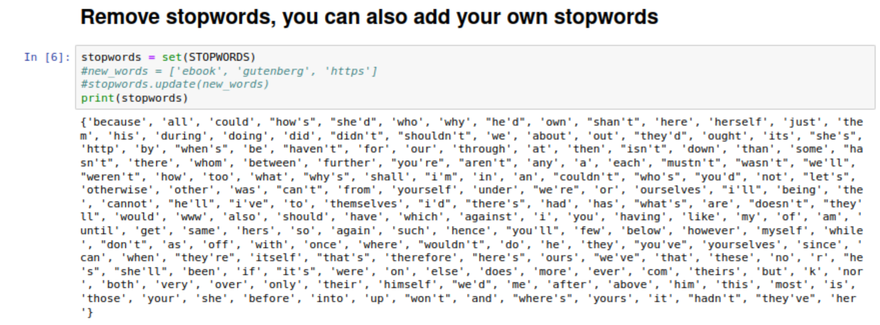

**Remove stop words, and stop words can be updated by using function update.**

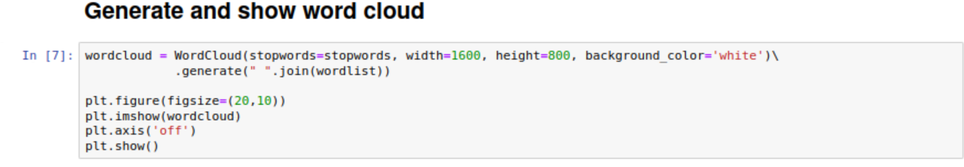

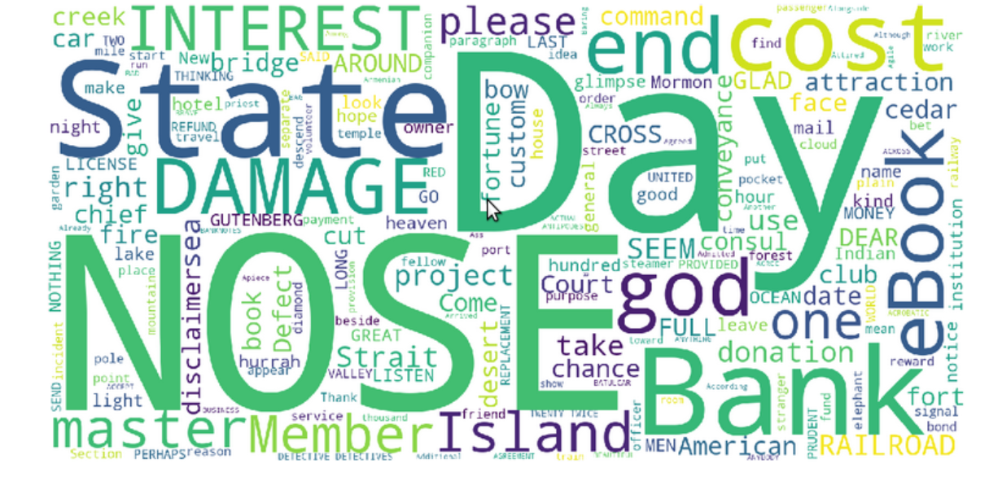

**Generate and show word cloud.**

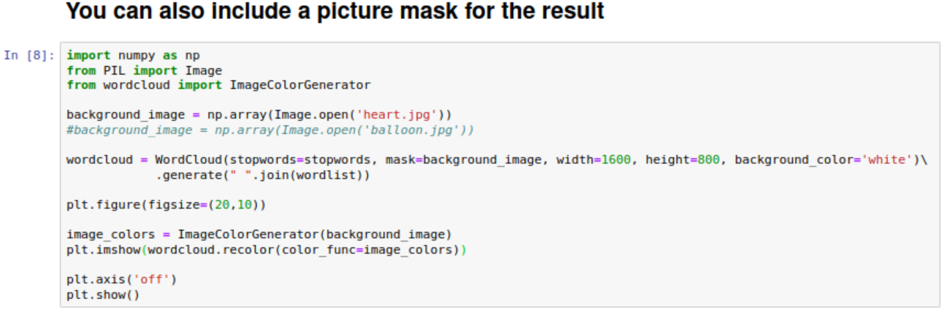

**Include a picture mask for the result.**

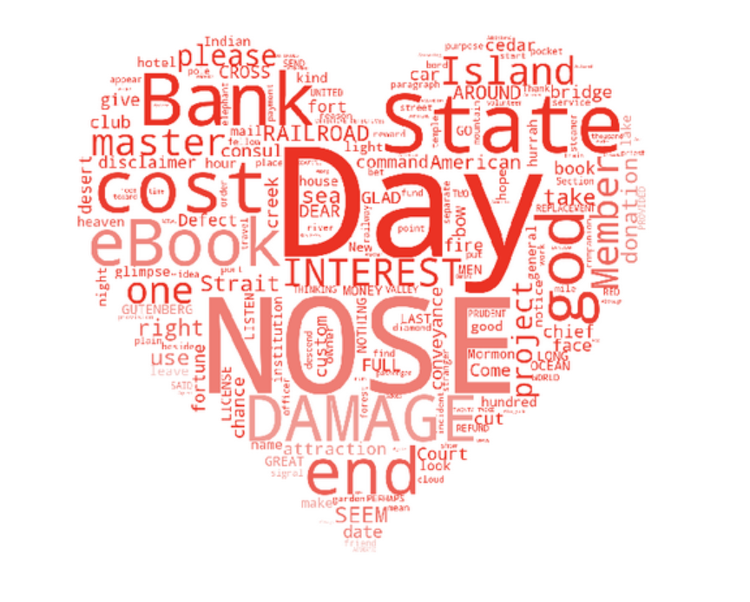

**The word cloud included a picture.**



**Run the word cloud for own Chinese text file.**

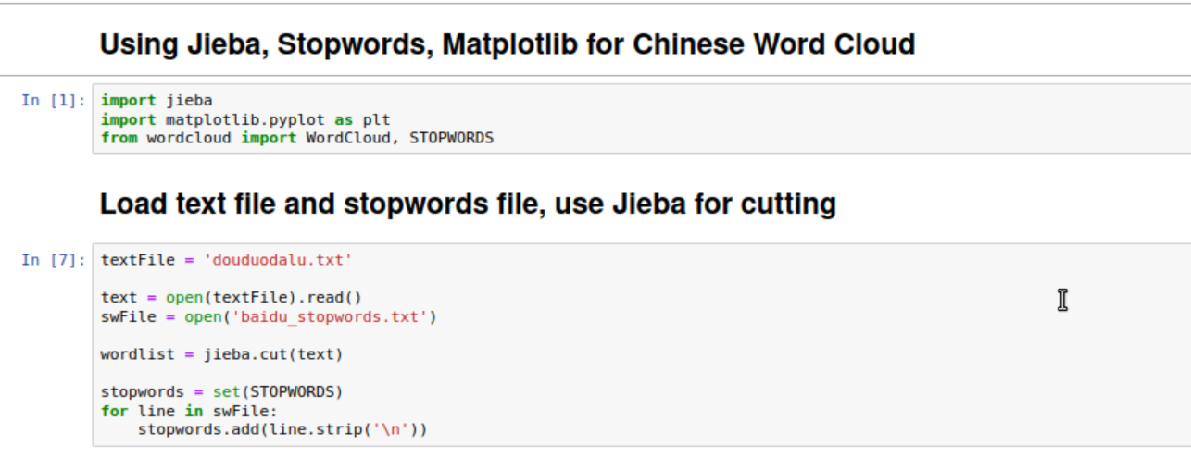

**Import libraries, load text file, stop words file and use Jieba for cutting.**

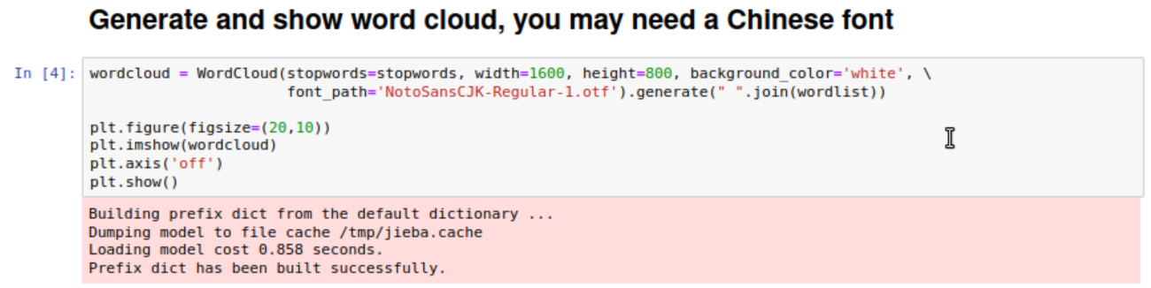

**Generate and show word cloud by using a Chinese font.**

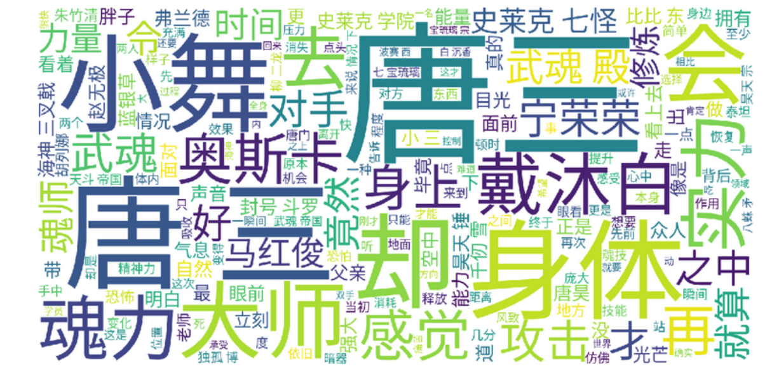

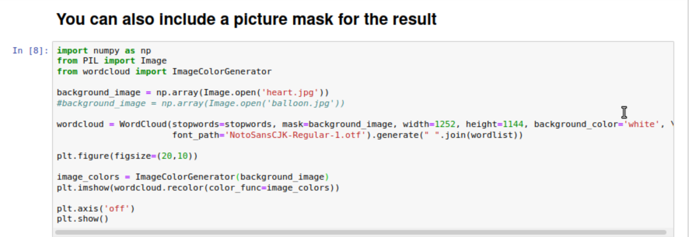

**Include a picture for the word cloud.**



**Word cloud with a included picture.**

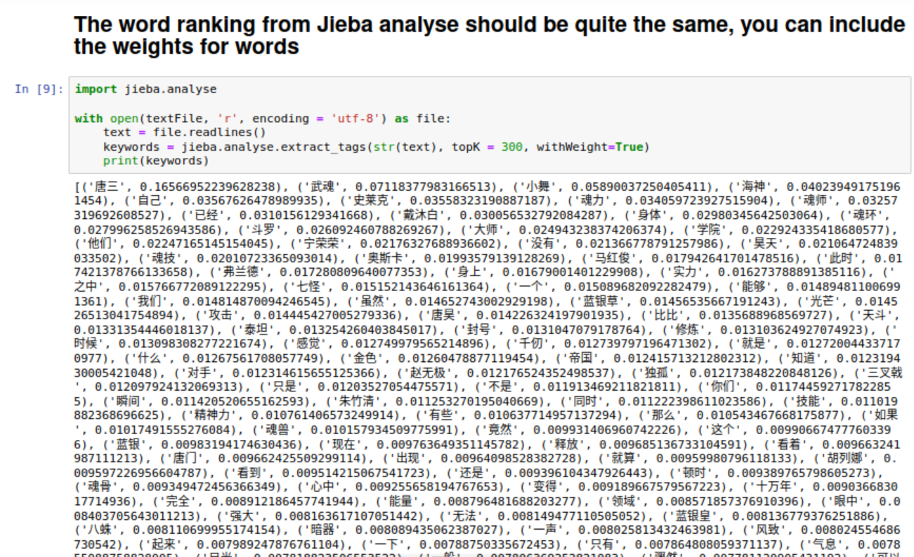

**Rank the word by Jieba Analyse.**

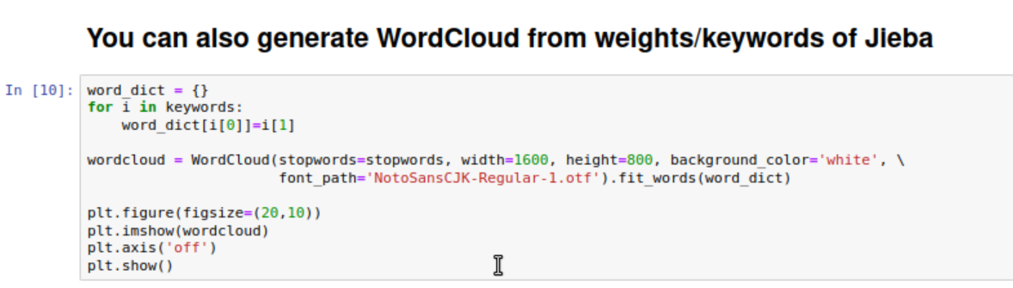

**Generate word cloud from weights of JIeba.**

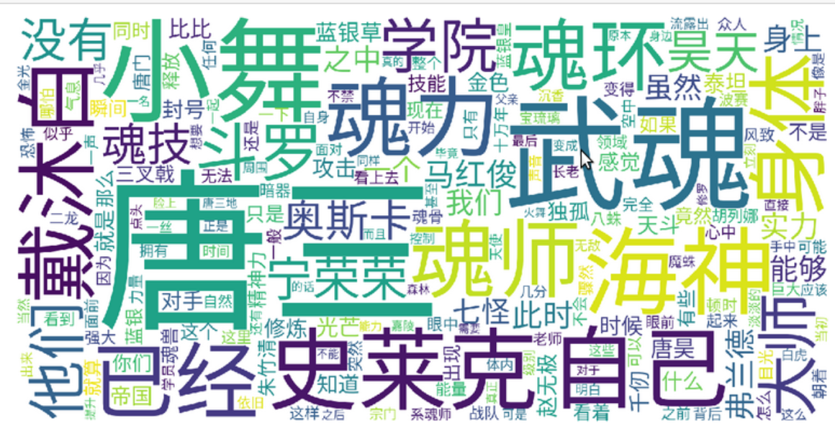

**Word cloud with weights**